

Royall Elementary school

Royall Intermediate School

May 18, 2022



Panther Parent Bulletin

**If you signed up for baseball/softball this summer, please pay your $10 fee**

Thursday, May 26 – 1:15 p.m. Early Dismissal

**Summer School**

Summer school will run Monday – Thursday, June 6 – 23. Classes will be in the Elementary School from 7:45 a.m. – 12:30 p.m. All students will receive free breakfast and free lunch. The 3rd through 7th grade volleyball will be in the elementary gym, and basketball will be in the high school gym from 12:30 – 1:30 p.m. Pick up for these classes will be at 1:30 p.m. at the flag pole.

**FREE Breakfast & Lunch**

Summer lunches will be served Monday through Thursday, June 6 – July 28 from 11:30 to 12:30 p.m. at the Elroy Commons and the Kendall gazebo. Meals will also be served from 12:30 to 1:30 at Schultz Park. There will be no meals on July 4. Meals are free to everyone 18 and under. Pre orders are not required but would be helpful. Watch the Royall School Facebook page for the lunch menu.

Any questions feel free to contact Kristi Shore at 462-6315.

**End of the Year**

The last day of school for students will be Thursday, May 26.

**End of the Year Field Trips**

**Mon., May 23**

4K Winnebago Park, Tomah

**Wed., May 25**

K Robot World, Wisc. Dells

1st Deer Park, Wisc. Dells

2nd Timbavati, Wisc. Dells

3rd Wisc. Ducks & Mini-Golf, Wisc. Dells

4th Jet Boat Tour & Rocky Arbor Park, Dells

5th Upper Dells Boat Tour, Wisc. Dells

6th LaCrosse Queen & Myrick Park, LaCrosse

**Class Rosters & Supply List**

When you receive your Back to School letter in the beginning of August, your child will find out who their teacher is for the upcoming school year. This is the best way to handle so many students moving in and out during the summer, and that way we can keep the classes balanced academically, socially, and behaviorally. Thank you for your understanding.

****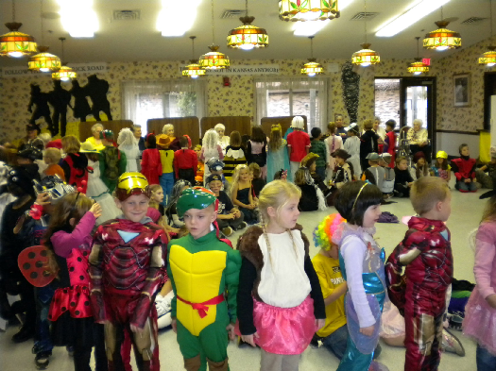 

**Fri., May 20 – 4K Graduation at 10:00**

**Elementary Gym**

**Thurs., May 26 – 2 Hour Early Dismissal**

**Soccer Reminder**

WASL Soccer registrations were sent home.  If you lost your registration form you can find it on the WASL Facebook site.

**Elroy Food Pantry**

The Elroy Food Pantry is open every Thursday from 1:00 – 2:30 p.m. at Grace Lutheran Church. This is open to anyone in the Royall or Wonewoc-Center School Districts.

**Last 26 Days of School**

19 - **U**nique and Unusual

20 - **V**ictory (Wear a shirt of a team that has had victories!)

23 - **W**isconsin Day (wear red and white to support our Wisconsin Badgers)

24 - e**X**ercise Clothes

25 - **Y**ellow Day (wear your Royall Gear to support our school)

26 - **Z**oo animal (wear a shirt with an animal on it or an animal print)

**Have a Wonderful Summer!**

**Safe Arrival Policy**

Parents need to call the school and advise the office when their child is absent. Telephone calls need to be made by 8:30 a.m. When no call or note is received, the office will be contacting a parent at work or home to find out where the student is.

may 18, 2022

Reminders

PLACE LOGO OR

COMPANY NAME HERE

PLACE PHOTO HERE,

OTHERWISE DELETE BOX

PLACE PHOTO HERE,

OTHERWISE DELETE BOX